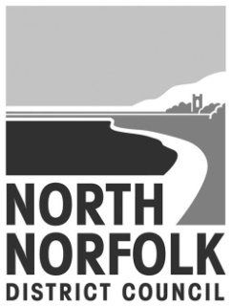
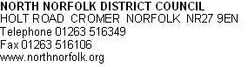

Our Ref:
Direct Dial: (01263) 516349
Direct Fax: (01263) 516106

CLAIMANT NAME
CLAIMANT ADDRESS

Dear Customer,

Housing Benefit Payments

Claimants that are subject to Local Housing Allowance are not as a general rule able to opt to have their benefit paid directly to their landlord. However there are some circumstances where the authority can consider making direct payments if it is deemed to be in the overriding interests of the claimant to do so.

In addition to this there are also safeguards in place with a view to protecting landlords and to stop claimants who cannot manage their rent payments from falling into arrears.

If you think that by having direct payments to you will cause you serious problems, please complete this form and return it to us.

Yours sincerely,
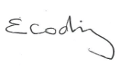
Elisabeth Codling
Benefits Manager
Tel (01263) 516349
Between: 8.30am – 5.00pm Monday, Tuesday, and Thursday
10.00am – 5.00pm Wednesday and 8.30am – 4.30pm Friday
Email: benefits@north-norfolk.gov.uk

Payment to Landlord Request Form

Claimant’s name:

Claimant’s address:

Claim ref:

Please tick the box or boxes that apply to you and provide the evidence required.

Reason direct payment is a problem | Evidence required
I have learning disabilities that  Make it difficult to manage my  Finances. | Written evidence from Care Workers, your GP, Social Services, etc.
I have a medical condition or mental  health problem which makes it  difficult to manage my finances. | Written evidence from Care Workers, your GP, Social Services, etc.
I have serious difficulties with  reading and writing. | Written evidence from Support Organisations.
I do not speak English. | Written evidence from Support Organisations.
I am dealing with addiction to drugs,  alcohol or gambling. | Written evidence from Support Organisations, your GP, Social Services, Care Workers, Hospital, etc.
I am fleeing domestic violence. | Written evidence from Support Organisations, Social Services, etc.
I have recently been released from  Prison. | Written evidence from the Prison or the Probation Service.
I have severe debt problems. | Court Orders, CCJs, evidence from Help Groups, Solicitors, creditors, debt advisers, etc.
I am an undischarged bankrupt. | Copy of Court Order.
I am unable to open a bank  account. | Letters from banks or money advisers.

I have a history of homelessness. | Evidence from Support Organisations, Homeless Charity, etc.
None of the problems above apply to me, but direct payments will be
difficult for me because:
__________________________________________

__________________________________________________________________

__________________________________________________________________

Please use this space to tell us anything else you would like us to consider

__________________________________________________________________

__________________________________________________________________

__________________________________________________________________

Contact telephone number

Declaration
Even if someone else has filled in this form for you, you must sign this declaration if you can.

I declare that the information I have given in this form is correct and
I authorise you to make enquiries to check any of the information or
evidence I have provided.

Signature

Date

If this form has been completed by someone other than the
tenant, they must complete the declaration below.

I declare that, as far as possible, I have confirmed with the
tenant that the information I have written on this form is correct.

Name of the person
who filled in the form

Relationship to the tenant

Signature
Date

